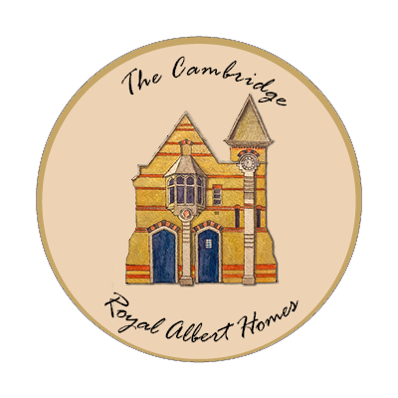

Terms and conditions
Please read these Terms of Use (Terms) carefully before using this website. Use of this site constitutes your acceptance of these Terms, which take effect on the date that you first use the site. If you do not agree to these Terms (note in particular the disclaimers at Terms 6 and 7), please do not use this site.
1. Access and use of this site is provided by the Cambridge Royal Albert Homes charity. References in these Terms to "we" or "us" or "our" refer to the Cambridge Royal Albert Homes.
2. The Cambridge Royal Albert Homes reserves the right to change these Terms at any time. Please check these Terms on a regular basis for changes. Your continued use of the site after changes are posted will mean you accept the Terms as modified by the posted changes.
3. Where you have provided contact details the Cambridge Royal Albert Homes may contact you arising from the information you have provided.
4. You agree to use this site only for lawful purposes, and in a manner that does not infringe the rights of anyone else, nor restrict or inhibit their use and enjoyment of this site.
5. Copyright and trademarks - all material on this site is the copyright of the Cambridge Royal Albert Homes or third parties. Read our copyright and trademarks information.
6. The material on this site is provided for general information only and is not intended as specific advice. Whilst we try to ensure that the information on the site is accurate, we can accept no responsibility for the accuracy of the site content. Users who rely on the information in the site do so at their own risk. This site is made available for public viewing solely on the basis that the Cambridge Royal Albert Homes excludes to the extent lawfully permitted all liability whatsoever for any loss or damage arising out of use of this site, or reliance upon its contents.
7. We do not warrant that the functions contained on this site will be uninterrupted or error free, that defects will be corrected, or that this site or the server that makes it available are free of viruses or bugs, or represent full functionality, accuracy or reliability of the materials. We cannot accept any liability for any loss, disruption or damage to your data or your computer system which may occur as a result of you using this site.
8. We reserve the right in our sole discretion to deny any user access to this site or any part of it without prior notice.
9. This site may contain links to other websites.
10. If there is any conflict between these Terms and any rules or specific terms of use appearing elsewhere on this site relating to specific material, then those specific terms or rules shall prevail.
11. If any of these Terms should be determined to be illegal, invalid or otherwise unenforceable by reason of the laws of any state or country in which these Terms are intended to be effective, then to the extent and within that jurisdiction in which that Term is illegal, invalid or unenforceable, it shall be severed and deleted from these Terms and the remaining terms shall survive, remain in full force and effect, and continue to be binding and enforceable.
12. These Terms and use of this site shall be governed by English law. All claims or disputes arising out of or in connection with this site shall be subject to the exclusive jurisdiction of the courts of England. However, the Cambridge Royal Albert Homes shall have the right to commence and prosecute any legal or equitable action or proceeding before any court of competent jurisdiction to obtain injunctive and other relief in respect of the infringement of intellectual property rights.

The Cambridge Royal Albert Homes
28 Royal Albert Homes
120 Hills Road
Cambridge
​CB2 1PP

Charity number 1190144

August 2021

