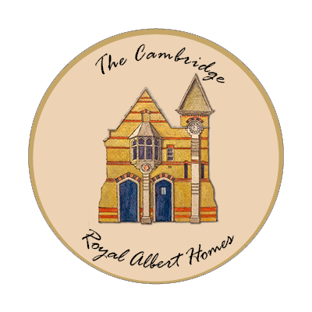

Accessibility
Our goal is to make this website as accessible as possible and easy to use for everyone. We aim to comply with the AA standard of the W3C web content accessibility guidelines (WCAG). Find out more about W3C and web accessibility. We developed the design and layout of the site to be compatible with screen readers and it can be navigated without the use of a mouse or keyboard. We are making every effort to ensure that we don't exclude any users. For example by:
- using clear and simple language
- providing meaningful alternative text for images
- ensuring the target of each link is clearly defined
- providing a sitemap
- ensuring the HTML code we produce conforms to the standard: XHTML; 1.0 Transitional.
We also try to publish all our text content as accessible HTML rather than in other formats such as PDF.
Please contact us if you have any questions, if you are having difficulties using the site, or would like to know more about what we are doing to make our websites accessible.

The Cambridge Royal Albert Homes
28 Royal Albert Homes
120 Hills Road
Cambridge
​CB2 1PP

Charity number 1190144

